Chapter 8, Solution 24.

The switch in the circuit of Fig. 16.47 has been closed for a long time but is opened at t = 0. Determine i(t) for t > 0.

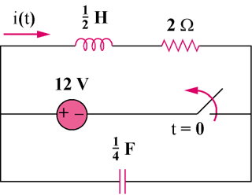

Figure 16.47
For Prob. 16.24.
8.20

Solution

Step 1. First we solve for the initial conditions and then convert the circuit into the s-domain and then solve for I, perform a partial fraction expansion, then convert back into the time domain. We recognize that the capacitor becomes an open circuit and the inductor becomes a short circuit at t = 0–. Therefore, v(0) = 12 volts and i(0) = 12/2 = 6 amps.

2

0.5s

6/s

4/s
+ −

12/s

I

We can use mesh analysis, –(12/s) + (4/s)I + (0.5s)(I–6/s) + 2I = 0.

Step 2. [(4/s)+0.5s+2]I = (12/s)+(3) = (3s+12)/s = [(s²+4s+8)/(2s)]I or
I = (6s+24)/[(s+2+j2)(s+2–j2)] = [A/(s+2+j2)] + [B/(s+2–j2)] where
A = (–12–j12+24)/(–j4) = 16.97∠–45˚/4∠–90˚= 4.243∠45˚and
B = (–12+j12+24)/(j4) = 4.243∠–45˚. Thus,
i(t) = 4.243e^{–2t}[e^{–(j2t–45˚)}+e^{(j2t–45˚)}]u(t)

= 8.486e^{–2t}cos(2t–45˚) amps.

